Multiple-choice section – choose the correct answer

Question 1 [5.1]

The area of a rectangle (in mm2) of length 2 cm and width 0.03 m is:

A 600 B 60 C 120 D 1200

Question 2 [5.1]

The area of a circle of diameter 0.2 m is approximately:

A 3140 cm2 B 3.14 cm2 C 314 cm2 D 31.4 cm2

Question 3 [5.2]

The surface area of a rectangular prism (in cm2) of length 0.5 m, width 12 cm and height 30 mm is:

A 180 B 786 C 1572 D 81

Question 4 [5.3]

A 5 m length of copper pipe is bought for a new extension. It has an outer diameter of 50 mm and an inner diameter of 45 mm. Which of the following could be used to find the volume of copper (in m3) needed to make this pipe.

A ( × 502 –  × 452 ) × 5 B ( × 252 –  × 22.52 ) × 5000

C ( × (0.05 – 0.045))2 × 5 D ( × (0.0252 – 0.02252 ) × 5

Question 5 [5.4] [10A]

What is the surface area (in mm2) of a cone of base diameter 20 mm, whose slant length is twice as long as its base radius?

A  B  C  D 

Question 6 [5.4] [10A]

The outer surface area of a hemisphere (in cm2) of diameter 215 mm is close to:

A 726 B 1452 C 5809 D 2904

Question 7 [5.5] [10A]

The volume of a cone is 308 mm3 and its radius is 7 mm. Its height in mm is close to:

A 2 B 3 C 4 D 6

Question 8 [5.5] [10A]

What is the volume of a hemisphere (in m3) of diameter 3 m?

A  B  C  D 

Question 9 [5.7] [10A]

A metal cube of mass 640 g has edge length 2 cm. Its density in g/cm3 is:

A 80 B 128 C 8 D 64

Question 10 [5.7] [10A]

200 mL of salt water contains 80 mL of salt solution. The concentration of salt water in mL/10 mL is:

A 0.002 B 0.4 C 0.6 D 4

Multiple-choice results: ___ / 10

Short answer section

Question 11 2 marks [5.2, 5.4]

Use words from the list below to complete the following sentences.

surface area prism pyramid composite shape uniform cross-section

capacity tapered solid cylinder net volume

(a) It is not possible to construct a ____________ of a sphere.

(b) The expression 6x2 gives the ___________________________ of a cube of side length x.

Question 12 2 marks [5.5] [10A]

A hollow cylinder and cone have the same height, however the radius of the cylinder is twice as long as the radius of the cone. The cone is filled with water and then poured into the cylinder. How many times does this need to be done to fill the cylinder?

Question 13 3 marks [5.2]

Calculate the total surface area of the figure.

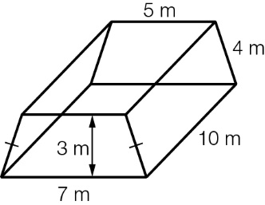

Question 14 3 marks [5.3]

Calculate the volume of a trapezoidal prism of length 20 cm if the height of the shape at its ends is 10 cm and the lengths of its two parallel sides are 5 cm and 8 cm.

Question 15 2 marks [5.3]

Calculate, in terms of π, the volume of a cylinder of height 10 cm whose radius of the base is half the height.

Question 16 4 marks [5.1, 5.4] [10A]

A hollow cone of diameter 20 cm and slant length 15 cm is to be constructed by cutting out the required shape from a rectangular sheet of cardboard of length 30 cm and width 20 cm.

(a) What is the surface area of the cone to the nearest cm2?

(b) What is the area of the cardboard?

(c) What area of cardboard is left over to the nearest cm2?

Question 17 3 marks [5.5] [10A]

A glass hemispherical bowl is of thickness 1 cm. If the inner radius of the bowl is 8 cm, what is the volume of the glass to the nearest cm3?

Question 18 3 marks [5.5] [10A]

A sphere of radius 30 cm is completely filled with liquid. The liquid is emptied into a cylinder of height 100 cm and radius 30 cm. What percentage of the cylinder contains liquid?

Question 19 2 marks [5.7] [10A]

Jack prepared 150 g of a saline solution containing 8 g of salt. What percentage concentration is the solution?

Question 20 3 marks [5.7] [10A]

The concentration of sugar in water is 12 g/125 mL. If 25 mL of water is added, how many grams of sugar must be added so that the concentration does not change?

Question 21 4 marks [5.6]

The area A of a trapezium of width h and with parallel side lengths of a and b is given by

(a) Rearrange the equation to make a the subject.

(b) Calculate the value of a when , cm and  cm.

Question 22 4 marks [5.6]

The surface area S of a cylinder is , where r is the radius of its base and h is its height.

(a) If , rearrange the equation to make r the subject.

(b) What is the value of r when ?

Short answer results: ___ / 35

Extended answer section

Question 23 4 marks [5.1]

Calculate the area of the shape, correct to 2 decimal places.

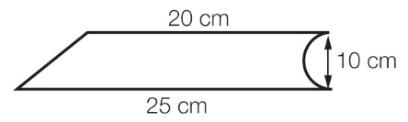

Question 24 3 marks [5.5] [10A]

Determine the value of the radius required so that the surface area of a sphere has the same value as its volume.

Question 25 5 marks [5.3]

A hole of diameter 1.5 cm is drilled parallel to the length of a block of wood of length 2 m, width 6 cm and height 10 cm. Give answers to the following correct to the nearest cm3.

(a) Find the volume of timber before any drilling occurred.

(b) What volume of timber was removed to make the hole?

(c) How much timber remains after the drilling?

Question 26 6 marks [5.1, 5.3]

The shape shown below is obtained by removing a quarter circle and a small right-angled triangle from a right-angled isosceles triangle. Give answers to the following correct to 2 decimal places.

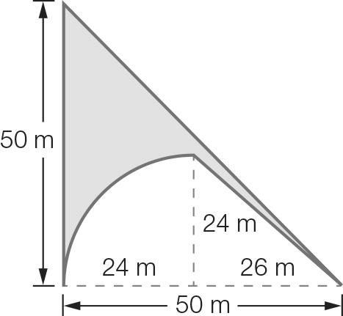

(a) Find the shaded area.

(b) The shape represents the cross-section of the base of a sculpture that is 3 m in height. What is the volume of the sculpture in cubic metres?

(c) The sculpture, which is made of metal, is to be melted and then reshaped to form a solid cube. What will be the length of each side of the cube?

Question 27 4 marks [5.3, 5.7] [10A]

The density of gold is 19 g/cm3. What is the edge length of a 1.5 kg gold ingot cube?

Extended answer results: ___ / 22

TOTAL test results: ___ / 67